CEEMS Poster Guidelines and Pointers
Speaker: Pamela Truesdell is a member of the Resource Team for the CEEMS Program at the UC. Her educational background includes a B.A. and MAT in History, as well as a B.S. in Education from UC. Pamela taught history, math, computer science, and engineering for 30 years in Cincinnati Public Schools. She served as the chairperson for the Engineering Department at Western Hills Engineering High School and was part of the committee that helped the school receive National Certification from Project Lead the Way Engineering in 2010. In 2011, Truesdell was selected for the Albert Einstein Distinguished Educator Fellowship program. She served for two years at the National Science Foundation working on the Research Experiences for Teachers in the Engineering Directorate. Pamela Truesdell also authored a short format book, Engineering Essentials for STEM Instruction: How do I infuse real-world problem solving into science, technology, and math? (ASCD Arias) which was co-released by ASCD and NSTA Press in April, 2014.
Date: Tuesday, July 12, 2016
Time: 9:00 – 11:00 am
Venue: University of Cincinnati, Swift 516
Prepared by:
Nancy A. Schreder-Vossen, Harrison High School, Harrison OH
RET Participant for Project #1: Applications of Nanocomposites on Controlling Biofilms in Drinking Water Distribution System

The workshop session CEEMS Poster Guidelines and Pointers Orientation, was delivered by Pamela Truesdell, a member of the Resource Team for the CEEMS Program at UC. The presentation took place at the University of Cincinnati on Tuesday, July 12, 2016 from 9:00 – 11:00 am at the University of Cincinnati in Zimmer, room 414. The objectives of the session were to teach participants how to: a) understand and apply the requirements of the summer poster and the unit poster to be created during the school year b) apply the Principals ad Elements of Design to improve poster design and use them in creating their own posters and c) evaluate sample posters and analyze how they could be improved.
Pamela Truesdell began the presentation by explaining that the poster is an importance deliverable because it can be used to communicate and summarize to students, principals, and other stakeholders the work the CEEMs/RET teacher has completed during the summer. It also can be used to start a conversation with parents, advertises the benefits of CBL projects, and provides one with the opportunity to participate in future conferences (figure 2).
Participants were given the checklist that outlines the expectations of the poster. This document allows for self- assessment and is also a good tool for collaboration between the CEEMS student and their mentor. The requirements of the poster can be divided into two categories, style and graphics. The main requirement for style focuses on font. All font sizes have to be at least 28pts and the same font (size and style) should be used in all major headings, sub-headings, and body text. The participants were reminded to restrict the number of fonts in the entire poster to no more than three. Information was also given to the participants on how to maximize the graphics on the poster. She provided the following helpful hints; pull accent colors from photos, ghost graphics and make sure the graphic applies to the topic. The final tips Pamela Truesdell gave the audience were to keep photos in high resolution, restrict the use of clip art, avoid canned photos and make sure that there is “white space”. Properly utilizing white space will create a place for the eyes to rest.

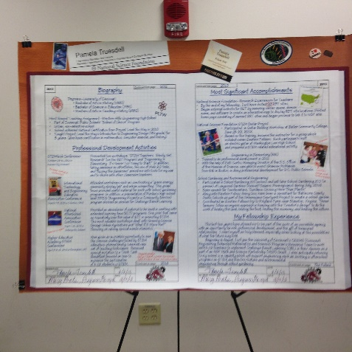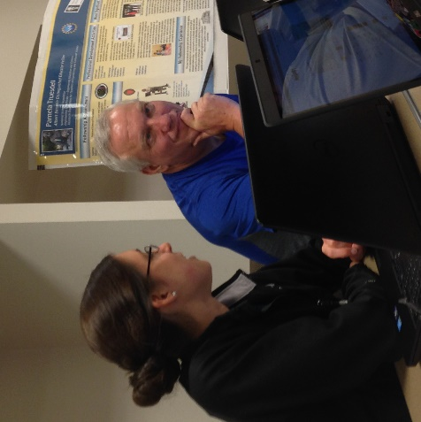
Figure 1: Sample of poster used at a conference Figure 2: CEEMS/RET participants critique poster

The next component of the workshop focused on the Principles and Elements of Design. The Principles outlined in the workshop were unity and variety, emphasis and focal point, scale and proportion, balance, and rhythm. According to the handout given during the presentation, these principles are the “laws” of designing anything. The Elements of Design are things that are involved in making a design. There are even elements of design; a) line b)shape and volume c) texture and pattern d) illustration of space e) illusion of motion, value and color. CEEMS and RET teachers used these guideline to evaluated posters from other teacher poster work. This gave the participants an opportunity to apply the concepts outlined in the handout (figure 1).
The presentation concluded with a question and answer session. Pamela Truesdell encourage all participants to attend the brown bag lunch session, if they needed further assistance.

